
Individual Analytical Analysis II Memo
To: Dr. David Willy
From: Ryan Navarette
Date: Wednesday, October 27th, 2021
Subject: Individual Analytical Analysis II - Option 2 new

INTRODUCTION:
The NASA RASC-AL (National Aeronautics and Space Administration Revolutionary Aerospace Systems Concepts - Academic Linkage) Lunar habitat capstone team is tasked to design a low-mass habitat that can support 2 astronauts at the lunar south pole for 30 days. The design constraints for this analytical project are a dry mass limit of 6000kg, a theoretical NASA budget of $1 billion per year from 2022-2028, and to be ready for first use in 2028. The purpose of this individual analysis is to implement design changes to top-level subassemblies and provide fastener solutions to major sub-assemblies in the current NASA RASC-AL prototype (particularly pertaining to the CAD model). Since the beginning of the semester, the team switch from the initial/proof-of-concept CAD (Computer-Aided Design) model and implemented numerous design changes into a new CAD model called the EDU (Engineering Design Unit). In the industry, it is common practice to create an EDU CAD assembly that will closely resemble your final product and is the next stage after the initial/proof-of-concept CAD model has been created. The design and subassemblies have progressed significantly since the ending of last semester and this memo covers four subsystems of the NASA RASC-AL lunar habitat that were the subjects of redesigns: Whipple shield, pressure wall, floor, and airlock.
SUBSYSTEMS:
- WHIPPLE SHIELD:
The Whipple shield is the outermost layer of the lunar habitat that serves to protect the astronauts from micrometeorites. There have been several design alterations, and as of now, the Whipple shield consist of 6 layers of alternating Kevlar and Nextel in between two aluminum sheets with another 3 layers of the MLI (Multi-Layer Insulation) being attached to the base of the rear bumper. Figures 1 and 2 show the change in the overall design from a cylindrical Whipple shield to a planar Whipple shield. The solution on how to secure and fasten the Whipple shield together was inspired by a Chinese design [1] and Figure 2 showcases this design implantation. The Whipple shield subassembly is held together by an ANSI-metric M24x3.0 bolt and washer combo; there are tapped holes on the minimum sheets and through holes on the MLI, Kevlar, and Nextel layers. Each Whipple shields square section measures 400mm by 400mm. Figure 12 in the Appendix show the dimensions for the custom cylindrical fastener component.

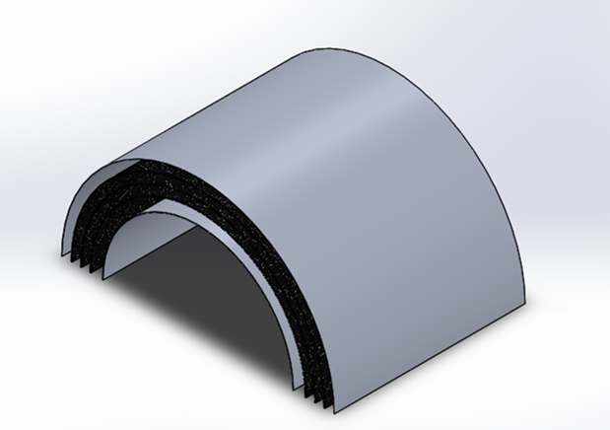
Figure 1: Previous Iteration of the Whipple Shield

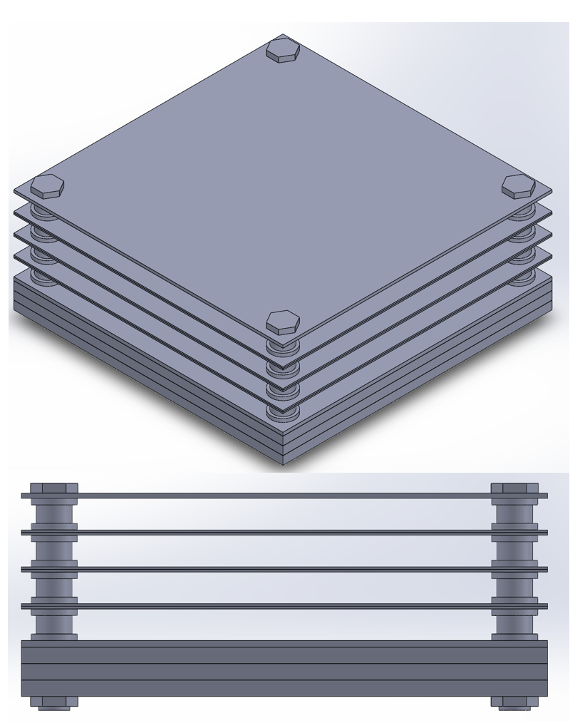
Figure 2: Updated Whipple Shield Design with Fasteners (Top) and Side-view of the Updated Whipple Shield Design with Fasteners (Bottom)

- PRESSURE WALL:
As per the analysis done in the hardware review, Aluminum 6061 T6 was selected to be used to construct the pressure wall. The original model of the pressure wall was simply an extruded cylinder that was used to convey design intent. After the SOLIDWORKS analysis confirmed that the pressure wall should have a minimum thickness of 25.4 mm (1 in) as seen in Figure 3, the CAD model was updated for the EDU assembly and can be seen in Figure 4. The pressure wall more closely resembles the shape of a gas tank and follows similar deign principals. There is a greater thickness of material where there is a turn and no sharp corners in the design to reduce the possibility of a rupture and to rid the pressure wall of potential stress risers. Figure 13 in the Appendix shows the dimensions of the updated EDU pressure wall.
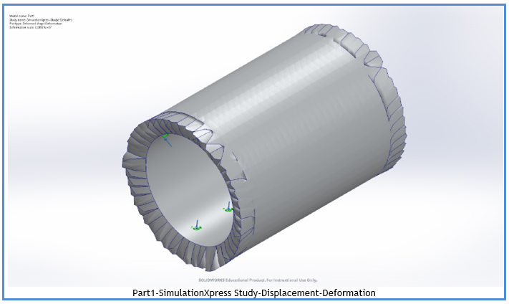
Figure 3: Previous Pressure Wall Displacement-Deformation SOLIDWORKS Simulation
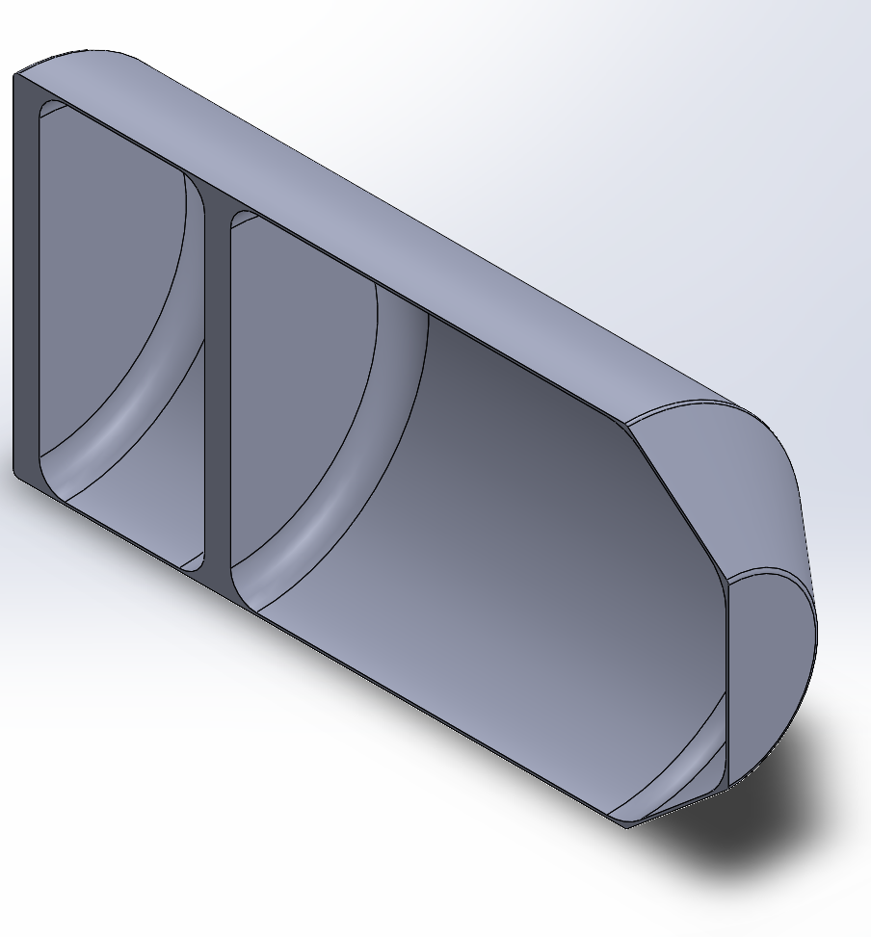
Figure 4: Updated EDU Pressure Wall
- FLOOR:
At the beginning of the semester, the CAD lead (myself), refined their CAD modeling skills by learning weldments. Weldments is a SOLIDWORKS feature that allows for a part or assembly to be modeled using pipe, rods, or tubing to generate components that will be welded together. This was used for the bone structure redesign and then used to add the structural members that will hold up the floor. The floor has space for storage and there is also room for the ECLSS (Environmental Control and Life Support System) that will be incorporated into the EDU design in the future. The habitable volume needed for the two astronauts is 50 m³, yet there is approximately 56 m³ of habitable volume featured in the EDU model. Figures 5 and 6 show the transition of the floor CAD models.

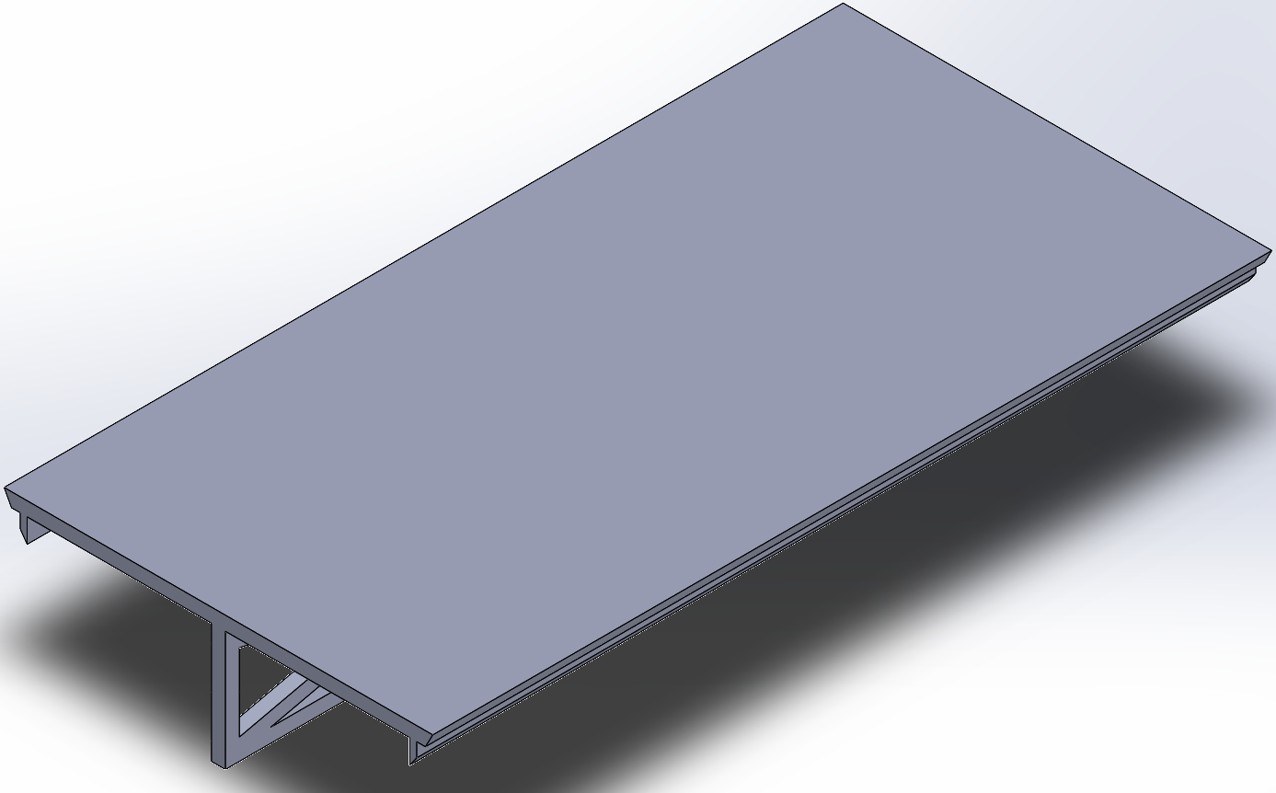
Figure 5: Previous CAD model for the Floor

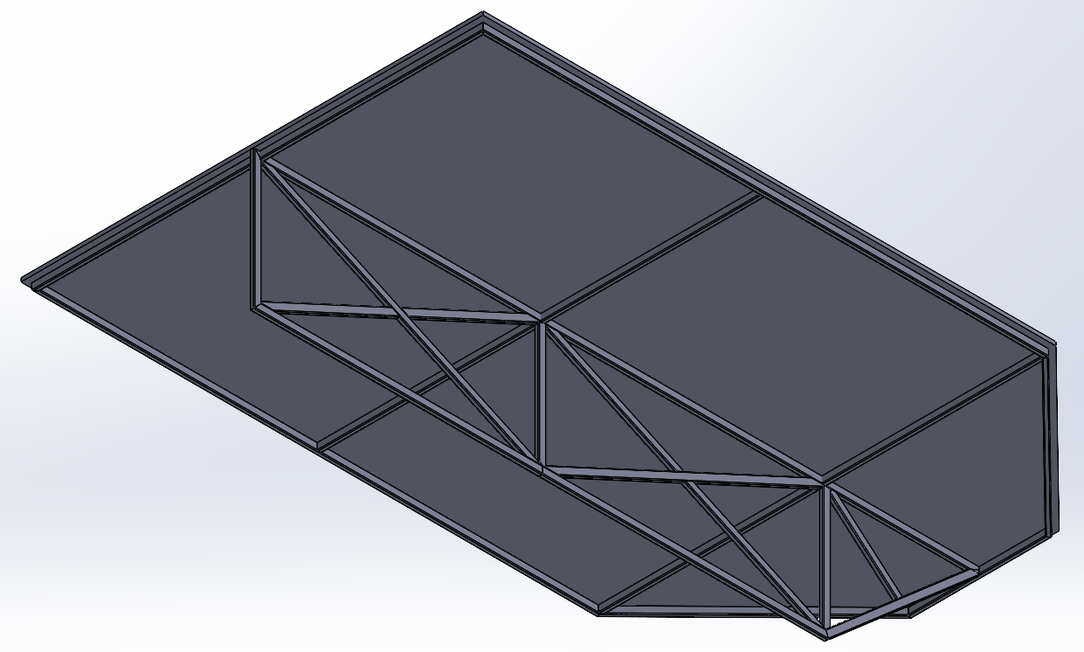
Figure 6: Updated CAD model of the Cabin Floor
- AIRLOCK:
The airlock components are still a work in progress as designing an air-tight locking system for a lunar habitat is a difficult task that requires time to understand and model. However, with the redesign of the pressure wall for the EDU CAD model, the section connecting the living quarters to the door leaning outside where the astronauts can put on their space suites and prepare for moon walks is accounted for. The walls on each side of this area is 254mm (10in) thick; this is so that when the airlock is opened the pressure on the door (leading to the crew quarters) is essentially the same. Figure 7 shows a cross-sectional view of the updated EDU CAD assembly without the Whipple shield.

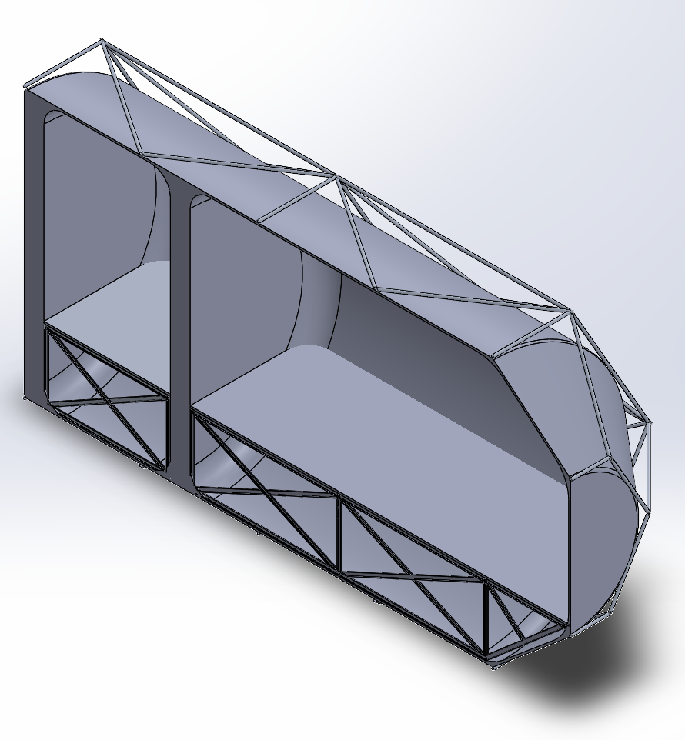
Figure 7: Cross-sectional view of the updated EDU CAD assembly (without the Whipple shield)
CONCLUSION:
Figures 8, 9, and 10 in the Appendix shows the previous CAD models of the habitat as it underwent design changes. A Whipple shield array of 5 by 15 is needed to completely cover one side of the hexagonal bone structure, as seen in Figure 11 in the Appendix. The floor design features approximately 56 m³ of habitable volume featured in the EDU model and an increase of storage room/ECLSS compartments. The airlock is Due to many redesigns of the subassemblies featured in the current EDU CAD model, the team has managed about half the size of the habitat (form the first design) and has reduced weight from the original 11,000kg weight of the Proof-of-Concept to the current EDU only weighing approximately 4,500kg. There is still more components and subassemblies of the lunar habitat that have yet to be incorporated into the current EDU CAD model (but could not make it into this memo due to time constraints). It is recommended at a simp-rep (simplified representation) of the CAD model be created as there are too many components on the master representation that is causing computer performance to plummet. The team is making good progress and is on schedule as reflected by the current state of the physical prototype and EDU CAD models.

REFERENCES:
[1] Putzar, R., Zheng, S.,etc. 2018. International Journal of Impact Engineering: “A stuffed Whipple shield for the Chinese space station.” Available: <https://www.sciencedirect.com/science/article/pii/S0734743X1830650X>

APPENDIX:
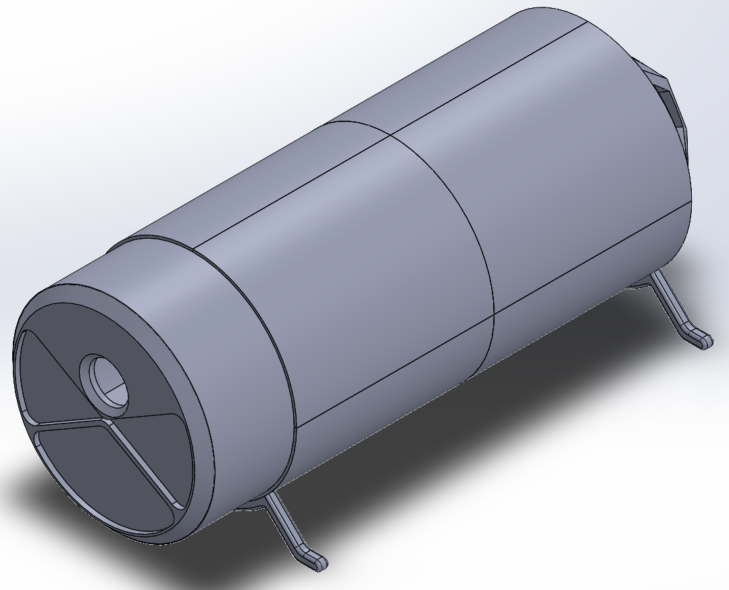
Figure 8: Proof of Concept model (beginning of Spring 2021 CAD model)
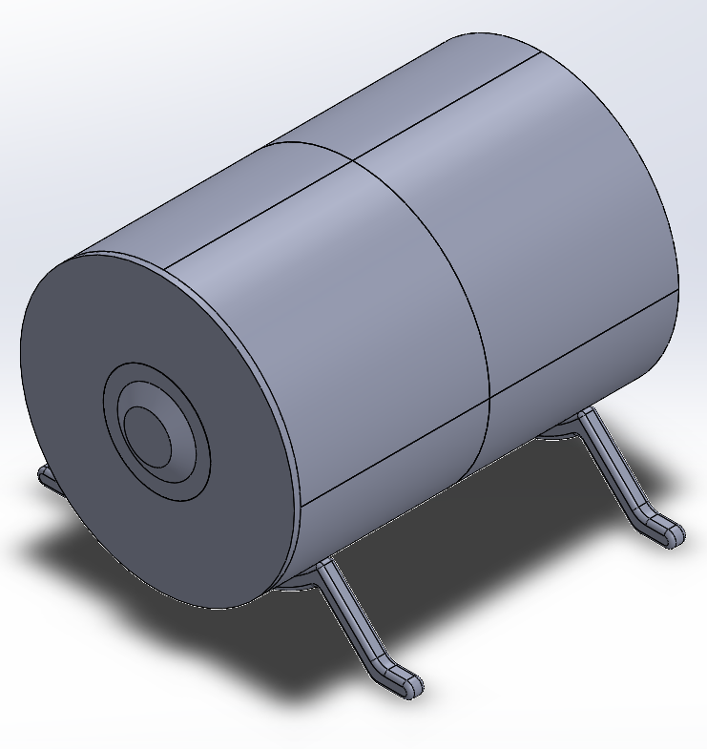
Figure 9: End of Spring 2021 semester CAD model
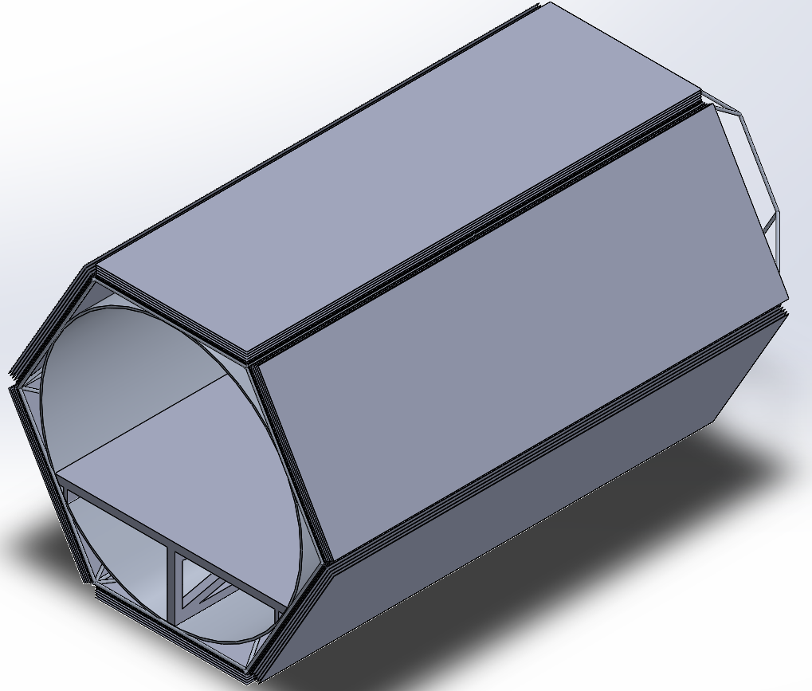
Figure 10: Original EDU CAD model
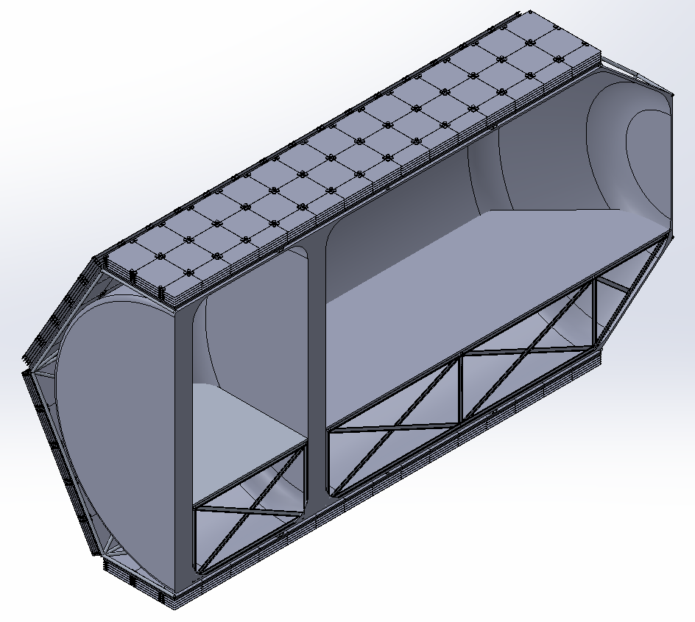
Figure 11: Cross-Sectional View of the Updated EDU CAD model

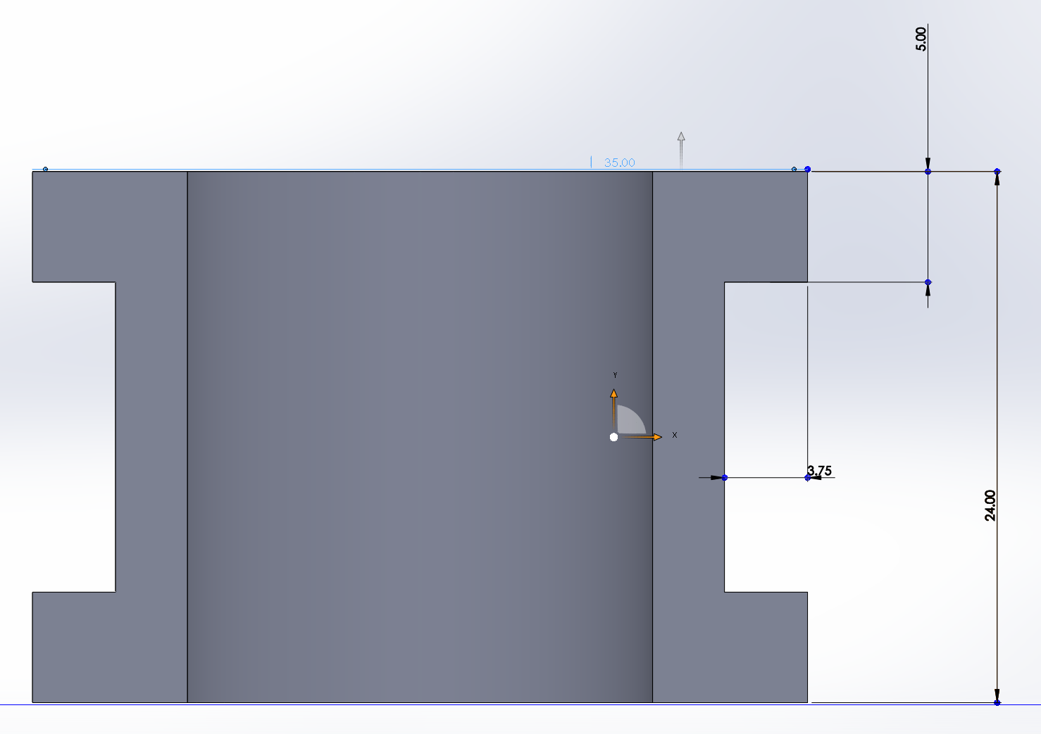
Figure 12: Dimensions of Whipple Shield Cylindrical Fastener Component
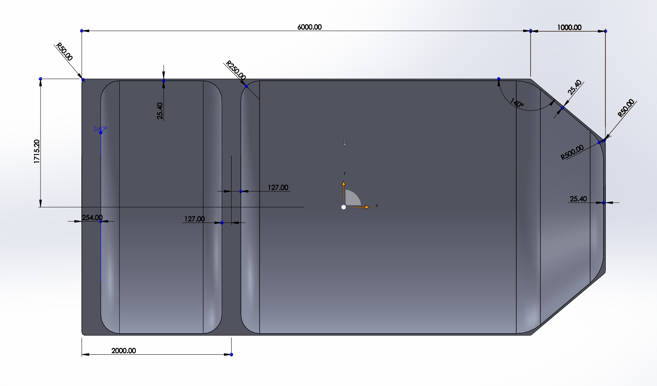
Figure 13: Dimensions of Updated Pressure Wall

